**39. Design DFA using simulator to accept the string the end with abc over set {a,b,c) W= abbaababc**

**AIM:** To design DFA using simulator to accept the string the end with abc over set {a,b,c) W= abbaababc

**TRANSITION DIAGRAM:**

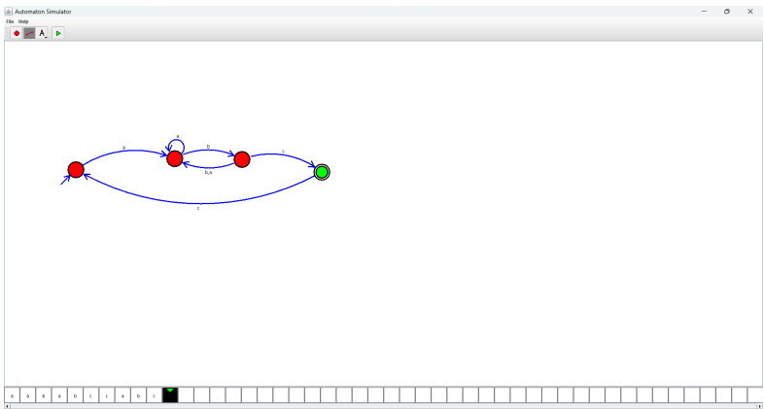

**RESULT**: Hence designing NFA using a simulator to accept the string that end with abc.